R for Biologists-Day_5

Maruf Ahmed Bhuiyan

7/10/2020

# 1. Create a variable “x” that has value 5. And another variable “y” that has value 3. Add them and store in z. Print z in the console.

x <- 5  
y <- 3  
z <- x + y  
z

## [1] 8

# 2. Create a vector called “tamim” with runs in five matches. The runs are 40, 50, 100, 20, 10, 35, 40. Get the average run of tamin in the tournament

## There are values for seven matches.

tamim <- c(40, 50, 100, 20, 10, 35, 40)  
tamim_average <- sum(tamim) / 7  
tamim_average

## [1] 42.14286

# Alternative approach  
tamim_average <- sum(tamim) / length(tamim)  
tamim_average

## [1] 42.14286

# We can also calculate the mean which is the arithmetic average.  
mean(tamim)

## [1] 42.14286

# 3. Create a boxplot of variable tamim. It should like like the following. Which one is the outlier here?

boxplot(tamim, main = " Scores of Tamim", ylab = "Runs scored", col = "cyan3")

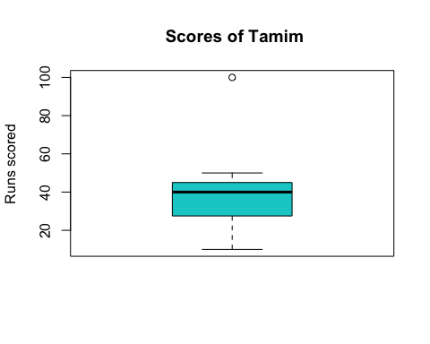

# Outlier is any value that is 1.5 times the IQR value above or   
# below the Q3 or Q1 correspondingly. The score 100 is the outlier here.  
  
print(paste("The outlier is:", 100))

## [1] "The outlier is: 100"

# 4. Create matrix with number 1 to 100. The matrix should contain 4 columns and 25 rows.

mat <- matrix(1:100, nrow = 25, ncol = 4)  
mat

## [,1] [,2] [,3] [,4]  
## [1,] 1 26 51 76  
## [2,] 2 27 52 77  
## [3,] 3 28 53 78  
## [4,] 4 29 54 79  
## [5,] 5 30 55 80  
## [6,] 6 31 56 81  
## [7,] 7 32 57 82  
## [8,] 8 33 58 83  
## [9,] 9 34 59 84  
## [10,] 10 35 60 85  
## [11,] 11 36 61 86  
## [12,] 12 37 62 87  
## [13,] 13 38 63 88  
## [14,] 14 39 64 89  
## [15,] 15 40 65 90  
## [16,] 16 41 66 91  
## [17,] 17 42 67 92  
## [18,] 18 43 68 93  
## [19,] 19 44 69 94  
## [20,] 20 45 70 95  
## [21,] 21 46 71 96  
## [22,] 22 47 72 97  
## [23,] 23 48 73 98  
## [24,] 24 49 74 99  
## [25,] 25 50 75 100

# 5. Give the 4 column names. “one, two, three, four”. It should look like following

colnames(mat) <- c("one", "two", "three", "four")  
mat

## one two three four  
## [1,] 1 26 51 76  
## [2,] 2 27 52 77  
## [3,] 3 28 53 78  
## [4,] 4 29 54 79  
## [5,] 5 30 55 80  
## [6,] 6 31 56 81  
## [7,] 7 32 57 82  
## [8,] 8 33 58 83  
## [9,] 9 34 59 84  
## [10,] 10 35 60 85  
## [11,] 11 36 61 86  
## [12,] 12 37 62 87  
## [13,] 13 38 63 88  
## [14,] 14 39 64 89  
## [15,] 15 40 65 90  
## [16,] 16 41 66 91  
## [17,] 17 42 67 92  
## [18,] 18 43 68 93  
## [19,] 19 44 69 94  
## [20,] 20 45 70 95  
## [21,] 21 46 71 96  
## [22,] 22 47 72 97  
## [23,] 23 48 73 98  
## [24,] 24 49 74 99  
## [25,] 25 50 75 100

# Alternate approach  
  
colname <- c("one", "two", "three", "four")  
colnames(mat) <- colname  
mat

## one two three four  
## [1,] 1 26 51 76  
## [2,] 2 27 52 77  
## [3,] 3 28 53 78  
## [4,] 4 29 54 79  
## [5,] 5 30 55 80  
## [6,] 6 31 56 81  
## [7,] 7 32 57 82  
## [8,] 8 33 58 83  
## [9,] 9 34 59 84  
## [10,] 10 35 60 85  
## [11,] 11 36 61 86  
## [12,] 12 37 62 87  
## [13,] 13 38 63 88  
## [14,] 14 39 64 89  
## [15,] 15 40 65 90  
## [16,] 16 41 66 91  
## [17,] 17 42 67 92  
## [18,] 18 43 68 93  
## [19,] 19 44 69 94  
## [20,] 20 45 70 95  
## [21,] 21 46 71 96  
## [22,] 22 47 72 97  
## [23,] 23 48 73 98  
## [24,] 24 49 74 99  
## [25,] 25 50 75 100

# 6. Create a data frame that looks like following.

Name <- c("William", "Emma", "Sofia", "Markus", "Edward", "Thomas")  
Region <- c("East", "North", "East", "South", "West", "West")  
Sales <- c(50000, 52000, 90000, 34000, 42000, 72000)  
Expenses <- c(42000, 43000, 50000, 44000, 38000, 39000)  
  
df <- data.frame(Name, Region, Sales, Expenses)  
df

## Name Region Sales Expenses  
## 1 William East 50000 42000  
## 2 Emma North 52000 43000  
## 3 Sofia East 90000 50000  
## 4 Markus South 34000 44000  
## 5 Edward West 42000 38000  
## 6 Thomas West 72000 39000

# 7. Create the following list:

mother <- "Veronique"  
father <- "Michel"  
sisters <- c("Alicia", "Monica")  
sisters_age <- c(12, 22)  
  
lst <- list(mother, father, sisters, sisters_age)  
lst

## [[1]]  
## [1] "Veronique"  
##   
## [[2]]  
## [1] "Michel"  
##   
## [[3]]  
## [1] "Alicia" "Monica"  
##   
## [[4]]  
## [1] 12 22

names(lst) <- c("mother", "father", "sisters", "sisters_age")  
lst

## $mother  
## [1] "Veronique"  
##   
## $father  
## [1] "Michel"  
##   
## $sisters  
## [1] "Alicia" "Monica"  
##   
## $sisters_age  
## [1] 12 22

# 8. Write an if else condition where it says, if x is greater than 0 then print positive, if less than 0 print negative and if x is 0 than print zero and if anything else print please type a new number. Check what the value shows if x <- 5 and x <- 0

x <- 5  
  
if (x > 0){  
 print("Positive")  
} else if (x < 0){  
 print("Negative")  
} else if (x == 0){  
 print("Zero")  
} else   
 print("Please, type a new number")

## [1] "Positive"

x <- 0  
  
if (x > 0){  
 print("Positive")  
} else if (x < 0){  
 print("Negative")  
} else if (x == 0){  
 print("Zero")  
} else   
 print("Please, type a new number")

## [1] "Zero"

# 9. Create the following data frame:

DF1 <- data.frame(c1 = c(1,5,14,23,54),   
 c2 = c(9,15,85,3,42),   
 c3 = c(9,7,42,87,16))  
DF1

## c1 c2 c3  
## 1 1 9 9  
## 2 5 15 7  
## 3 14 85 42  
## 4 23 3 87  
## 5 54 42 16

mat1 <- as.matrix(DF1)  
mat1

## c1 c2 c3  
## [1,] 1 9 9  
## [2,] 5 15 7  
## [3,] 14 85 42  
## [4,] 23 3 87  
## [5,] 54 42 16

# 10. Use for loop to get the following output

digits <- c(1:10)  
  
for (i in digits){  
 print(paste("the year is,", i))  
}

## [1] "the year is, 1"  
## [1] "the year is, 2"  
## [1] "the year is, 3"  
## [1] "the year is, 4"  
## [1] "the year is, 5"  
## [1] "the year is, 6"  
## [1] "the year is, 7"  
## [1] "the year is, 8"  
## [1] "the year is, 9"  
## [1] "the year is, 10"

# 11. Install Bioconductor in R. install Deseq2 package in R. Check the following

<https://www.bioconductor.org/packages/release/bioc/html/DESeq2.html>

# if (!requireNamespace("BiocManager", quietly = TRUE))  
# install.packages("BiocManager")  
# BiocManager::install(version = "3.10")  
  
# install Deseq2  
# if (!requireNamespace("BiocManager", quietly = TRUE))  
# install.packages("BiocManager")  
# BiocManager::install("DESeq2")

# 12. Load the inbuild “mtcars” data frame and store it as “cars”. If you View the cars you can see that the first column is “mpg” and fourth column is “hp”. Swap this column such that 1st column is “hp” and the fourth column is “mpg”.

data("mtcars")  
cars <- mtcars  
str(cars)

## 'data.frame': 32 obs. of 11 variables:  
## $ mpg : num 21 21 22.8 21.4 18.7 18.1 14.3 24.4 22.8 19.2 ...  
## $ cyl : num 6 6 4 6 8 6 8 4 4 6 ...  
## $ disp: num 160 160 108 258 360 ...  
## $ hp : num 110 110 93 110 175 105 245 62 95 123 ...  
## $ drat: num 3.9 3.9 3.85 3.08 3.15 2.76 3.21 3.69 3.92 3.92 ...  
## $ wt : num 2.62 2.88 2.32 3.21 3.44 ...  
## $ qsec: num 16.5 17 18.6 19.4 17 ...  
## $ vs : num 0 0 1 1 0 1 0 1 1 1 ...  
## $ am : num 1 1 1 0 0 0 0 0 0 0 ...  
## $ gear: num 4 4 4 3 3 3 3 4 4 4 ...  
## $ carb: num 4 4 1 1 2 1 4 2 2 4 ...

# View(cars)  
  
library(dplyr, quietly = TRUE)

##   
## Attaching package: 'dplyr'

## The following objects are masked from 'package:stats':  
##   
## filter, lag

## The following objects are masked from 'package:base':  
##   
## intersect, setdiff, setequal, union

cars %>% select("hp", "cyl", "disp",  
 "mpg", "drat", "wt",   
 "qsec", "vs", "am",   
 "gear", "carb")

## hp cyl disp mpg drat wt qsec vs am gear carb  
## Mazda RX4 110 6 160.0 21.0 3.90 2.620 16.46 0 1 4 4  
## Mazda RX4 Wag 110 6 160.0 21.0 3.90 2.875 17.02 0 1 4 4  
## Datsun 710 93 4 108.0 22.8 3.85 2.320 18.61 1 1 4 1  
## Hornet 4 Drive 110 6 258.0 21.4 3.08 3.215 19.44 1 0 3 1  
## Hornet Sportabout 175 8 360.0 18.7 3.15 3.440 17.02 0 0 3 2  
## Valiant 105 6 225.0 18.1 2.76 3.460 20.22 1 0 3 1  
## Duster 360 245 8 360.0 14.3 3.21 3.570 15.84 0 0 3 4  
## Merc 240D 62 4 146.7 24.4 3.69 3.190 20.00 1 0 4 2  
## Merc 230 95 4 140.8 22.8 3.92 3.150 22.90 1 0 4 2  
## Merc 280 123 6 167.6 19.2 3.92 3.440 18.30 1 0 4 4  
## Merc 280C 123 6 167.6 17.8 3.92 3.440 18.90 1 0 4 4  
## Merc 450SE 180 8 275.8 16.4 3.07 4.070 17.40 0 0 3 3  
## Merc 450SL 180 8 275.8 17.3 3.07 3.730 17.60 0 0 3 3  
## Merc 450SLC 180 8 275.8 15.2 3.07 3.780 18.00 0 0 3 3  
## Cadillac Fleetwood 205 8 472.0 10.4 2.93 5.250 17.98 0 0 3 4  
## Lincoln Continental 215 8 460.0 10.4 3.00 5.424 17.82 0 0 3 4  
## Chrysler Imperial 230 8 440.0 14.7 3.23 5.345 17.42 0 0 3 4  
## Fiat 128 66 4 78.7 32.4 4.08 2.200 19.47 1 1 4 1  
## Honda Civic 52 4 75.7 30.4 4.93 1.615 18.52 1 1 4 2  
## Toyota Corolla 65 4 71.1 33.9 4.22 1.835 19.90 1 1 4 1  
## Toyota Corona 97 4 120.1 21.5 3.70 2.465 20.01 1 0 3 1  
## Dodge Challenger 150 8 318.0 15.5 2.76 3.520 16.87 0 0 3 2  
## AMC Javelin 150 8 304.0 15.2 3.15 3.435 17.30 0 0 3 2  
## Camaro Z28 245 8 350.0 13.3 3.73 3.840 15.41 0 0 3 4  
## Pontiac Firebird 175 8 400.0 19.2 3.08 3.845 17.05 0 0 3 2  
## Fiat X1-9 66 4 79.0 27.3 4.08 1.935 18.90 1 1 4 1  
## Porsche 914-2 91 4 120.3 26.0 4.43 2.140 16.70 0 1 5 2  
## Lotus Europa 113 4 95.1 30.4 3.77 1.513 16.90 1 1 5 2  
## Ford Pantera L 264 8 351.0 15.8 4.22 3.170 14.50 0 1 5 4  
## Ferrari Dino 175 6 145.0 19.7 3.62 2.770 15.50 0 1 5 6  
## Maserati Bora 335 8 301.0 15.0 3.54 3.570 14.60 0 1 5 8  
## Volvo 142E 109 4 121.0 21.4 4.11 2.780 18.60 1 1 4 2

# 13. Make a scatter plot “mpg” vs “hp” and color it based on “gear”. What is the difference when you use factor and when you don’t

library(ggplot2)  
  
head(cars)

## mpg cyl disp hp drat wt qsec vs am gear carb  
## Mazda RX4 21.0 6 160 110 3.90 2.620 16.46 0 1 4 4  
## Mazda RX4 Wag 21.0 6 160 110 3.90 2.875 17.02 0 1 4 4  
## Datsun 710 22.8 4 108 93 3.85 2.320 18.61 1 1 4 1  
## Hornet 4 Drive 21.4 6 258 110 3.08 3.215 19.44 1 0 3 1  
## Hornet Sportabout 18.7 8 360 175 3.15 3.440 17.02 0 0 3 2  
## Valiant 18.1 6 225 105 2.76 3.460 20.22 1 0 3 1

# Without factorization  
ggplot(data = cars, aes(x = mpg , y = hp, colour= gear)) +   
 geom_point()

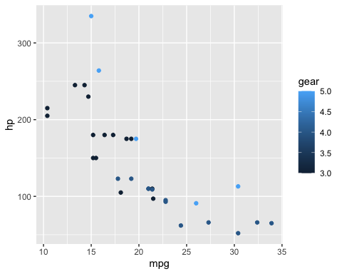

# With factorization  
ggplot(data = cars, aes(x = mpg , y = hp, colour= factor(gear))) +   
 geom_point()

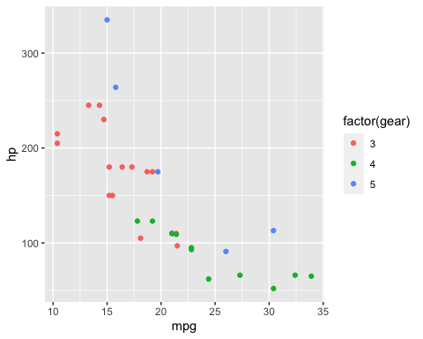

# We can make it more easy to understand using the shape argument  
ggplot(data = cars, aes(x = mpg , y = hp,   
 colour= factor(gear),   
 shape = factor(gear))) +   
 geom_point(size = 1.5)

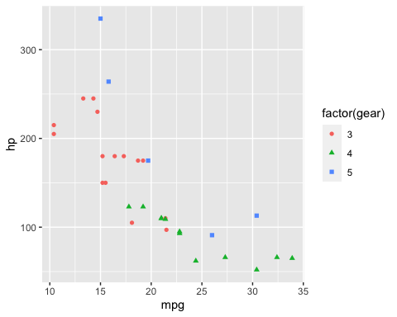

# 14. Load the file “house.csv” in R. you can see that the “aircond” column has 0 or 1. Where 0 means no facility of air-condition and 1 means containing facility of air-condition.

# Location of houses.csv file  
  
data <- read.csv("houses.csv")  
str(data)

## 'data.frame': 1728 obs. of 16 variables:  
## $ X.1 : int 1 2 3 4 5 6 7 8 9 10 ...  
## $ X : int 1 2 3 4 5 6 7 8 9 10 ...  
## $ price : int 132500 181115 109000 155000 86060 120000 153000 170000 90000 122900 ...  
## $ lot_size : num 0.09 0.92 0.19 0.41 0.11 0.68 0.4 1.21 0.83 1.94 ...  
## $ waterfront : int 0 0 0 0 0 0 0 0 0 0 ...  
## $ age : int 42 0 133 13 0 31 33 23 36 4 ...  
## $ land_value : int 50000 22300 7300 18700 15000 14000 23300 14600 22200 21200 ...  
## $ construction: int 0 0 0 0 1 0 0 0 0 0 ...  
## $ air_cond : int 0 0 0 0 1 0 0 0 0 0 ...  
## $ fuel : int 3 2 2 2 2 2 4 4 3 2 ...  
## $ heat : int 4 3 3 2 2 2 3 2 4 2 ...  
## $ sewer : int 2 2 3 2 3 2 2 2 2 1 ...  
## $ living_area : int 906 1953 1944 1944 840 1152 2752 1662 1632 1416 ...  
## $ fireplaces : int 1 0 1 1 0 1 1 1 0 0 ...  
## $ bathrooms : num 1 2.5 1 1.5 1 1 1.5 1.5 1.5 1.5 ...  
## $ rooms : int 5 6 8 5 3 8 8 9 8 6 ...

# 15. Make a new column titled “New_created_column” which contains “yes” or “no” value which is consistent with 0 and 1 in “aircond” column.

data <- data %>% mutate( "New_created_column" =   
 ifelse(air_cond ==0, "No",   
 ifelse(air_cond == 1, "Yes", NA)))  
  
head(data %>% select(air_cond, New_created_column))

## air_cond New_created_column  
## 1 0 No  
## 2 0 No  
## 3 0 No  
## 4 0 No  
## 5 1 Yes  
## 6 0 No

# 16. Make a boxplot with x axis as room number and y axis as price and compare how difference in price it makes if you have air condition facility or not. Use new_created_column.

ggplot(data = data, aes(x = factor(rooms),   
 y = price,   
 colour = factor(New_created_column))) +  
 geom_boxplot()

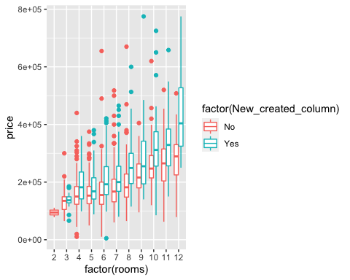

# 17. Create a frequency polygon with facet_grid based on “New_created_column”

ggplot(data = data, aes(x = price,   
 col = factor(New_created_column)))+   
 geom_freqpoly(bins = 100) +  
 facet_grid( ~ New_created_column)

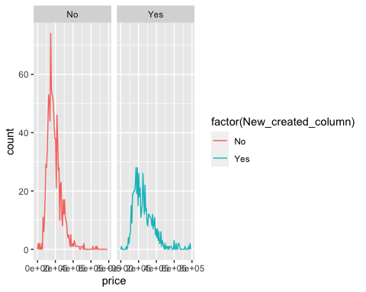

# 18. Say you have three genes EGFR, FOX1, TF1. You have calculated that in three cell type “cell1, cell2, cell3”. You want to create a matrix where each gene will have a value for each cell type

cell_1 <- c(10, 100, 12)  
cell_2 <- c(12, 12, 2)  
cell_3 <- c(15, 20, 3)  
  
data2 <- data.frame(cell_1, cell_2, cell_3)  
data2 <- as.matrix(data2)  
rownames(data2) <- c("EGFR", "TF_1", "FOX_1")  
data2

## cell_1 cell_2 cell_3  
## EGFR 10 12 15  
## TF_1 100 12 20  
## FOX_1 12 2 3

# 19. Calculate the mean of each row and add it as the fourth column and calculate the row sum and add it as the fifth column

Mean <- round(rowMeans(data2),2)  
  
Total <- rowSums(data2)  
  
cbind(data2, Mean, Total)

## cell_1 cell_2 cell_3 Mean Total  
## EGFR 10 12 15 12.33 37  
## TF_1 100 12 20 44.00 132  
## FOX_1 12 2 3 5.67 17

# 20. Say you have collected some samples from 5 person. You have asked them if they believe in aliens. The response was as follows:

responses <- factor(c("Agree", "Agree", "Strongly Agree", "Disagree", "Agree"))  
  
levels(responses) <- c("Strongly Agree", "Agree", "Disagree")  
responses

## [1] Strongly Agree Strongly Agree Disagree Agree Strongly Agree  
## Levels: Strongly Agree Agree Disagree

# 21. Create the following data frame,

Age <- as.numeric(c(25, 31, 23, 52, 76, 49, 26))  
Height <- as.numeric(c(177, 163, 190, 179, 163, 183, 164))  
Weight <- as.numeric(c(57, 69, 83, 75, 70, 83, 53))  
Sex <- factor(c("F", "F", "M", "M", "F", "M", "F"))  
  
levels(Sex) <- c("F", "M")  
  
df <- data.frame(Age, Height, Weight, Sex)  
df

## Age Height Weight Sex  
## 1 25 177 57 F  
## 2 31 163 69 F  
## 3 23 190 83 M  
## 4 52 179 75 M  
## 5 76 163 70 F  
## 6 49 183 83 M  
## 7 26 164 53 F

rownames(df) <- c("Alex", "Lilly", "Mark", "Oliver", "Martha", "Lucas", "Caroline")  
df

## Age Height Weight Sex  
## Alex 25 177 57 F  
## Lilly 31 163 69 F  
## Mark 23 190 83 M  
## Oliver 52 179 75 M  
## Martha 76 163 70 F  
## Lucas 49 183 83 M  
## Caroline 26 164 53 F

df_recoded <- df %>% mutate(Sex = recode(Sex, "F" = "M", "M" = "F"))  
rownames(df_recoded) <- c("Alex", "Lilly", "Mark",   
 "Oliver", "Martha", "Lucas", "Caroline")  
df_recoded

## Age Height Weight Sex  
## Alex 25 177 57 M  
## Lilly 31 163 69 M  
## Mark 23 190 83 F  
## Oliver 52 179 75 F  
## Martha 76 163 70 M  
## Lucas 49 183 83 F  
## Caroline 26 164 53 M

# 22.Create this data frame (make sure you import the variable Working as character and not factor).

Working <- c("Yes", "No", "No", "Yes", "Yes", "No", "Yes")  
class(Working)

## [1] "character"

df_working <- data.frame(Working, stringsAsFactors = F)  
rownames(df_working) <- c("Alex", "Lilly", "Mark", "Oliver", "Martha", "Lucas", "Caroline")  
  
  
df_new <- cbind(df, df_working)  
df_new

## Age Height Weight Sex Working  
## Alex 25 177 57 F Yes  
## Lilly 31 163 69 F No  
## Mark 23 190 83 M No  
## Oliver 52 179 75 M Yes  
## Martha 76 163 70 F Yes  
## Lucas 49 183 83 M No  
## Caroline 26 164 53 F Yes

nr <- nrow(df_new)  
nc <- ncol(df_new)  
  
print(paste("Rows:", nr, "Columns:", nc))

## [1] "Rows: 7 Columns: 5"

lapply(df_new, class)

## $Age  
## [1] "numeric"  
##   
## $Height  
## [1] "numeric"  
##   
## $Weight  
## [1] "numeric"  
##   
## $Sex  
## [1] "factor"  
##   
## $Working  
## [1] "character"

# 23. Write two string “hello” and “why am I doing this”. Add this two string together and separate by “,”

string1 <- "Hello"  
string2 <- "why am I doing this"  
str3 <- "because Sohan vai told me to do so !!"  
  
print(paste(string1, string2, str3, sep = ", "))

## [1] "Hello, why am I doing this, because Sohan vai told me to do so !!"

# 24. If name_list <- list(a = 1:200, b = “this is a string”, c = “hello”). You will write a code that will add 1 to each element of the first vector of the new list. Also, add a new item z = “newItem” to the list name_list

name_list <- list(a = 1:200, b = "this is a string", c = "hello")  
name_list

## $a  
## [1] 1 2 3 4 5 6 7 8 9 10 11 12 13 14 15 16 17 18  
## [19] 19 20 21 22 23 24 25 26 27 28 29 30 31 32 33 34 35 36  
## [37] 37 38 39 40 41 42 43 44 45 46 47 48 49 50 51 52 53 54  
## [55] 55 56 57 58 59 60 61 62 63 64 65 66 67 68 69 70 71 72  
## [73] 73 74 75 76 77 78 79 80 81 82 83 84 85 86 87 88 89 90  
## [91] 91 92 93 94 95 96 97 98 99 100 101 102 103 104 105 106 107 108  
## [109] 109 110 111 112 113 114 115 116 117 118 119 120 121 122 123 124 125 126  
## [127] 127 128 129 130 131 132 133 134 135 136 137 138 139 140 141 142 143 144  
## [145] 145 146 147 148 149 150 151 152 153 154 155 156 157 158 159 160 161 162  
## [163] 163 164 165 166 167 168 169 170 171 172 173 174 175 176 177 178 179 180  
## [181] 181 182 183 184 185 186 187 188 189 190 191 192 193 194 195 196 197 198  
## [199] 199 200  
##   
## $b  
## [1] "this is a string"  
##   
## $c  
## [1] "hello"

name_list[["a"]]

## [1] 1 2 3 4 5 6 7 8 9 10 11 12 13 14 15 16 17 18  
## [19] 19 20 21 22 23 24 25 26 27 28 29 30 31 32 33 34 35 36  
## [37] 37 38 39 40 41 42 43 44 45 46 47 48 49 50 51 52 53 54  
## [55] 55 56 57 58 59 60 61 62 63 64 65 66 67 68 69 70 71 72  
## [73] 73 74 75 76 77 78 79 80 81 82 83 84 85 86 87 88 89 90  
## [91] 91 92 93 94 95 96 97 98 99 100 101 102 103 104 105 106 107 108  
## [109] 109 110 111 112 113 114 115 116 117 118 119 120 121 122 123 124 125 126  
## [127] 127 128 129 130 131 132 133 134 135 136 137 138 139 140 141 142 143 144  
## [145] 145 146 147 148 149 150 151 152 153 154 155 156 157 158 159 160 161 162  
## [163] 163 164 165 166 167 168 169 170 171 172 173 174 175 176 177 178 179 180  
## [181] 181 182 183 184 185 186 187 188 189 190 191 192 193 194 195 196 197 198  
## [199] 199 200

add_vector <- rep.int(x = 1, 200)  
add_vector

## [1] 1 1 1 1 1 1 1 1 1 1 1 1 1 1 1 1 1 1 1 1 1 1 1 1 1 1 1 1 1 1 1 1 1 1 1 1 1  
## [38] 1 1 1 1 1 1 1 1 1 1 1 1 1 1 1 1 1 1 1 1 1 1 1 1 1 1 1 1 1 1 1 1 1 1 1 1 1  
## [75] 1 1 1 1 1 1 1 1 1 1 1 1 1 1 1 1 1 1 1 1 1 1 1 1 1 1 1 1 1 1 1 1 1 1 1 1 1  
## [112] 1 1 1 1 1 1 1 1 1 1 1 1 1 1 1 1 1 1 1 1 1 1 1 1 1 1 1 1 1 1 1 1 1 1 1 1 1  
## [149] 1 1 1 1 1 1 1 1 1 1 1 1 1 1 1 1 1 1 1 1 1 1 1 1 1 1 1 1 1 1 1 1 1 1 1 1 1  
## [186] 1 1 1 1 1 1 1 1 1 1 1 1 1 1 1

a <- name_list[["a"]] + add_vector  
a

## [1] 2 3 4 5 6 7 8 9 10 11 12 13 14 15 16 17 18 19  
## [19] 20 21 22 23 24 25 26 27 28 29 30 31 32 33 34 35 36 37  
## [37] 38 39 40 41 42 43 44 45 46 47 48 49 50 51 52 53 54 55  
## [55] 56 57 58 59 60 61 62 63 64 65 66 67 68 69 70 71 72 73  
## [73] 74 75 76 77 78 79 80 81 82 83 84 85 86 87 88 89 90 91  
## [91] 92 93 94 95 96 97 98 99 100 101 102 103 104 105 106 107 108 109  
## [109] 110 111 112 113 114 115 116 117 118 119 120 121 122 123 124 125 126 127  
## [127] 128 129 130 131 132 133 134 135 136 137 138 139 140 141 142 143 144 145  
## [145] 146 147 148 149 150 151 152 153 154 155 156 157 158 159 160 161 162 163  
## [163] 164 165 166 167 168 169 170 171 172 173 174 175 176 177 178 179 180 181  
## [181] 182 183 184 185 186 187 188 189 190 191 192 193 194 195 196 197 198 199  
## [199] 200 201

name_list <- list(a = a, b = "this is a string",   
 c = "hello", z = "newItem")  
name_list

## $a  
## [1] 2 3 4 5 6 7 8 9 10 11 12 13 14 15 16 17 18 19  
## [19] 20 21 22 23 24 25 26 27 28 29 30 31 32 33 34 35 36 37  
## [37] 38 39 40 41 42 43 44 45 46 47 48 49 50 51 52 53 54 55  
## [55] 56 57 58 59 60 61 62 63 64 65 66 67 68 69 70 71 72 73  
## [73] 74 75 76 77 78 79 80 81 82 83 84 85 86 87 88 89 90 91  
## [91] 92 93 94 95 96 97 98 99 100 101 102 103 104 105 106 107 108 109  
## [109] 110 111 112 113 114 115 116 117 118 119 120 121 122 123 124 125 126 127  
## [127] 128 129 130 131 132 133 134 135 136 137 138 139 140 141 142 143 144 145  
## [145] 146 147 148 149 150 151 152 153 154 155 156 157 158 159 160 161 162 163  
## [163] 164 165 166 167 168 169 170 171 172 173 174 175 176 177 178 179 180 181  
## [181] 182 183 184 185 186 187 188 189 190 191 192 193 194 195 196 197 198 199  
## [199] 200 201  
##   
## $b  
## [1] "this is a string"  
##   
## $c  
## [1] "hello"  
##   
## $z  
## [1] "newItem"

# 25. Download the small_counts.txt from the following location

# file <- "https://figshare.com/s/1d788fd384d33e913a2a"  
# dest <- paste(getwd(), "small_counts.txt", sep = "/")  
# dest  
  
# if (file.exists(dest) == !T) {  
# download.file(file, dest, method = "wget", mode = "w")  
# } else {  
# print("File is already downloaded !")  
# }  
  
### This is a link to the folder. We can download it manually   
## by going to the browser and opening the folder and downloading   
## the file manually.  
  
### Or we can download the file from R by the direct link to the file.  
"https://ndownloader.figshare.com/files/6005547?private_link=1d788fd384d33e913a2a"

## [1] "https://ndownloader.figshare.com/files/6005547?private_link=1d788fd384d33e913a2a"

file <- "https://ndownloader.figshare.com/files/6005547?private_link=1d788fd384d33e913a2a"  
dest <- paste(getwd(), "small_counts.txt", sep = "/")  
dest

## [1] "/Users/marufahmedbhuiyan/Desktop/cBALST_R/Day 5- 10 July 2020/small_counts.txt"

if (file.exists(dest) == !T) {  
 download.file(file, dest, method = "auto")  
} else {  
 print("File is already downloaded !")  
}

## [1] "File is already downloaded !"

# 26. Read the file in R and save it as small_counts. View the file.

small_counts <- read.table("small_counts.txt", header = TRUE)  
small_counts

## Sample_1 Sample_2 Sample_3 Sample_4  
## Xkr4 438 300 65 237  
## Sox17 106 182 82 105  
## Mrpl15 309 234 337 300  
## Lypla1 652 515 948 935  
## Tcea1 1604 1495 1721 1317  
## Rgs20 4 2 14 4  
## Atp6v1h 769 752 1062 987  
## Rb1cc1 1494 1412 1157 967  
## Pcmtd1 1344 1242 1374 1593  
## Rrs1 1691 1808 2127 1653

#View(small_counts)

# 27. Get the following output from the file

small_counts[,1:2]

## Sample_1 Sample_2  
## Xkr4 438 300  
## Sox17 106 182  
## Mrpl15 309 234  
## Lypla1 652 515  
## Tcea1 1604 1495  
## Rgs20 4 2  
## Atp6v1h 769 752  
## Rb1cc1 1494 1412  
## Pcmtd1 1344 1242  
## Rrs1 1691 1808

# 28. Get log of the small_count so that it looks like the following

log(small_counts)

## Sample_1 Sample_2 Sample_3 Sample_4  
## Xkr4 6.082219 5.7037825 4.174387 5.468060  
## Sox17 4.663439 5.2040067 4.406719 4.653960  
## Mrpl15 5.733341 5.4553211 5.820083 5.703782  
## Lypla1 6.480045 6.2441669 6.854355 6.840547  
## Tcea1 7.380256 7.3098815 7.450661 7.183112  
## Rgs20 1.386294 0.6931472 2.639057 1.386294  
## Atp6v1h 6.645091 6.6227363 6.967909 6.894670  
## Rb1cc1 7.309212 7.2527624 7.053586 6.874198  
## Pcmtd1 7.203406 7.1244783 7.225481 7.373374  
## Rrs1 7.433075 7.4999765 7.662468 7.410347

# 29. Download the “ResultsTable_small.txt” from the following location “<https://figshare.com/s/1d788fd384d33e913a2a>”

### This is a link to the folder. We can download it manually   
### by going to the browser and opening the folder and   
### downloading the file manually.  
  
### Or we can download the file from R by the direct link to the file.  
# "https://ndownloader.figshare.com/files/6005550?private_link=1d788fd384d33e913a2a"  
  
file <-   
 "https://ndownloader.figshare.com/files/6005550?private_link=1d788fd384d33e913a2a"  
dest <- paste(getwd(), "ResultsTable_small.txt", sep = "/")  
dest

## [1] "/Users/marufahmedbhuiyan/Desktop/cBALST_R/Day 5- 10 July 2020/ResultsTable_small.txt"

if (file.exists(dest) == !T) {  
 download.file(file, dest, method = "auto")  
} else {  
 print("File is already downloaded !")  
}

## [1] "File is already downloaded !"

# 30. This is a file which contains the gene expression data. The Entrez id is the gene name. You can search Entrez id in google to get more information.Symbol is the gene name. And “logFC” value which means how much more a gene is expressed in treatment condition compared to control condition. Read the file in R and store it as “results”.

results <- read.table(dest, header = T)  
head(results)

## ENTREZID SYMBOL logFC AveExpr t P.Value adj.P.Val  
## 1 24117 Wif1 1.819943 2.975545 20.10780 1.063770e-10 1.01624e-06  
## 2 381290 Atp2b4 -2.143885 3.944066 -19.07495 1.982934e-10 1.01624e-06  
## 3 78896 1500015O10Rik 2.807548 3.036519 18.54773 2.758828e-10 1.01624e-06  
## 4 226101 Myof -2.329744 6.223525 -18.26861 3.297667e-10 1.01624e-06  
## 5 16012 Igfbp6 -2.896115 1.978449 -18.21525 3.413066e-10 1.01624e-06  
## 6 231830 Micall2 2.253400 4.760597 18.02627 3.858161e-10 1.01624e-06

str(results)

## 'data.frame': 40 obs. of 7 variables:  
## $ ENTREZID : int 24117 381290 78896 226101 16012 231830 16669 55987 231991 14620 ...  
## $ SYMBOL : Factor w/ 40 levels "1500015O10Rik",..: 40 3 1 26 20 23 21 8 9 16 ...  
## $ logFC : num 1.82 -2.14 2.81 -2.33 -2.9 ...  
## $ AveExpr : num 2.98 3.94 3.04 6.22 1.98 ...  
## $ t : num 20.1 -19.1 18.5 -18.3 -18.2 ...  
## $ P.Value : num 1.06e-10 1.98e-10 2.76e-10 3.30e-10 3.41e-10 ...  
## $ adj.P.Val: num 1.02e-06 1.02e-06 1.02e-06 1.02e-06 1.02e-06 ...

# 31. Sort the file such thath the genes are orderd in highest to lowest value of “logFC”.

head(results[,1:3], 10)

## ENTREZID SYMBOL logFC  
## 1 24117 Wif1 1.819943  
## 2 381290 Atp2b4 -2.143885  
## 3 78896 1500015O10Rik 2.807548  
## 4 226101 Myof -2.329744  
## 5 16012 Igfbp6 -2.896115  
## 6 231830 Micall2 2.253400  
## 7 16669 Krt19 -2.312721  
## 8 55987 Cpxm2 -1.515469  
## 9 231991 Creb5 -2.598105  
## 10 14620 Gjb3 3.600094

head(results[order(-results$logFC),],10)

## ENTREZID SYMBOL logFC AveExpr t P.Value adj.P.Val  
## 22 16878 Lif 3.738933 6.682034 13.73344 9.105708e-09 6.541210e-06  
## 10 14620 Gjb3 3.600094 3.525281 16.46627 1.113755e-09 1.718703e-06  
## 25 12977 Csf1 2.835624 7.477591 13.41902 1.187300e-08 7.505634e-06  
## 3 78896 1500015O10Rik 2.807548 3.036519 18.54773 2.758828e-10 1.016240e-06  
## 15 11636 Ak1 2.766745 4.303475 15.27694 2.664640e-09 2.807465e-06  
## 26 12654 Chil1 2.342914 5.576457 13.21976 1.408760e-08 8.306595e-06  
## 29 217166 Nr1d1 2.278879 6.260878 13.12885 1.524242e-08 8.306595e-06  
## 6 231830 Micall2 2.253400 4.760597 18.02627 3.858161e-10 1.016240e-06  
## 13 74747 Ddit4 2.180370 6.864791 15.70145 1.938279e-09 2.356351e-06  
## 20 17131 Smad7 1.972771 6.717519 14.14348 6.493642e-09 5.131276e-06

# 32. See the following figure

Type the above code in your console and check counts_matrix to see what does it create. What do you think “rpois” comment did here? And try to find what is the difference between paste and paste0. Always remember “google” is your friend.

counts_matrix <- data.frame(cell_1 = rpois(10,10),  
 cell_2 = rpois(10,10),  
 cell_3 = rpois(10, 30))  
rownames(counts_matrix) <- paste0("gene_", 1:10)  
counts_matrix <- as.matrix(counts_matrix)  
counts_matrix

## cell_1 cell_2 cell_3  
## gene_1 6 12 37  
## gene_2 10 11 29  
## gene_3 4 8 34  
## gene_4 9 13 34  
## gene_5 18 8 31  
## gene_6 8 12 32  
## gene_7 11 13 28  
## gene_8 13 6 25  
## gene_9 9 8 21  
## gene_10 12 9 40

# What do you think “rpois” comment did here? And try to find what is the difference between paste and paste0.  
  
## rpois generates a Poisson distribution with random deviates. Other similar terms are dpois (density), qpois(quantile), ppois (log distribution function)  
  
## The Poisson distribution is the discrete probability distribution of the number of events occurring in a given time period, given the average number of times the event occurs over that time period.  
  
## The difference between paste() and paste0() is that the argument sep by default is " " (paste) and "" (paste0). paste0() is faster than paste() if our objective is concatenate strings without spaces because we don’t have to specify the argument sep. For example...see the difference between these..  
  
paste0("gene_", 1:10)

## [1] "gene_1" "gene_2" "gene_3" "gene_4" "gene_5" "gene_6" "gene_7"   
## [8] "gene_8" "gene_9" "gene_10"

paste("gene_", 1:10)

## [1] "gene_ 1" "gene_ 2" "gene_ 3" "gene_ 4" "gene_ 5" "gene_ 6"   
## [7] "gene_ 7" "gene_ 8" "gene_ 9" "gene_ 10"

# 33. Create a heatmap from the using the following file: Explain what was done in each line. Use “##” to comment on your code file in R

Load the file “basketball.csv”. Make sure you change the read.csv location from the following code.

The code will/might show you error!.copy the error and put it in google and see what is the suggestion from the internet. Try to understand and solve the problem. The end of the code will show something like the following:

file.exists("basketball.csv")

## [1] TRUE

# importing the file

nba <- read.csv("basketball.csv")

# sorting the file accoring to PTS in increasing order

nba <- nba[order(nba$PTS),]

# Naming the rownames according to the Name column

row.names(nba) <- nba$Name

# Subsetting the data frame with all rows and

# 20 columns except the first one

nba <- nba[,2:20]

# Creating a matrix

nba_matrix <- data.matrix(nba)

# Creating a heatmap  
nba_heatmap <- heatmap(nba_matrix, Rowv = NA,   
 Colv = NA,   
 col = cm.colors(256),  
 scale = "column",  
 margins = c(5,10))

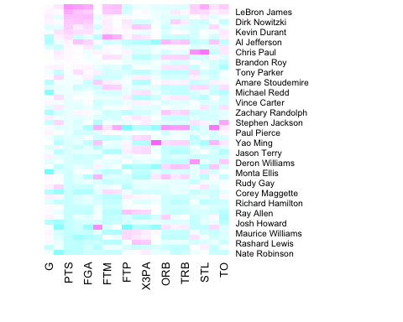

# The code didn't show any error to me ! So, let's continue  
  
# I prefer the following color scheme better  
nba_heatmap <- heatmap(nba_matrix, Rowv = NA,   
 Colv = NA,   
 col = heat.colors(256),  
 scale = "column",  
 margins = c(5,10))

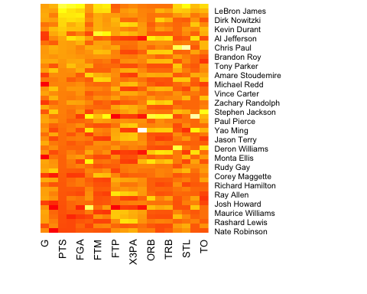

# Blue is my favorite color. So, let's color it blue !!  
if (!require("RColorBrewer")) {  
install.packages("RColorBrewer")  
library(RColorBrewer)  
}

## Loading required package: RColorBrewer

nba_heatmap <- heatmap(nba_matrix, Rowv = NA,   
 Colv = NA,   
 col = brewer.pal(9, "Blues"),  
 scale = "column",  
 margins = c(5,10))

